

Veermata Jijabai Technological Institute, Mumbai 400019

**Assignment No.:** 04

**Aim :** Modeling UML Class Diagrams and Sequence diagrams.

Case Study :

1. Hotel Management.  
2. Mess system in your hostel.  
3. Flight booking system.  
4. Grocery store management.

**Name :** Kiran K Patil **Enrollment No.:** 211070904 **Branch :** Computer Engineering **Batch:** IV

**Theory**

**UML - Statechart Diagrams**

The name of the diagram itself clarifies the purpose of the diagram and other details. It describes different states of a component in a system. The states are specific to a component/object of a system.

A Statechart diagram describes a state machine. State machine can be defined as a machine which defines different states of an object and these states are controlled by external or internal events.

Activity diagram explained in the next chapter, is a special kind of a Statechart diagram. As Statechart diagram defines the states, it is used to model the lifetime of an object.

**Purpose of Statechart Diagrams**

Statechart diagram is one of the five UML diagrams used to model the dynamic nature of a system. They define different states of an object during its lifetime and these states are changed by events. Statechart diagrams are useful to model the reactive systems. Reactive systems can be defined as a system that responds to external or internal events. Following are the main purposes of using Statechart diagrams −

* To model the dynamic aspect of a system.
* To model the life time of a reactive system.
* To describe different states of an object during its life time.
* Define a state machine to model the states of an object

**How to Draw a Statechart Diagram?**

Statechart diagram is used to describe the states of different objects in its life cycle. Emphasis is placed on the state changes upon some internal or external events. These states of objects are important to analyze and implement them accurately. Before drawing a Statechart diagram we should clarify the following points :

* Identify the important objects to be analyzed.
* Identify the states.
* Identify the events

**Where to Use Statechart Diagrams?**

Statechart diagram defines the states of a component and these state changes are dynamic in nature. Its specific purpose is to define the state changes triggered by events. Events are internal or external factors influencing the system. The main usage can be described as −

* To model the object states of a system.
* To model the reactive system. Reactive system consists of reactive objects.
* To identify the events responsible for state changes.
* Forward and reverse engineering.

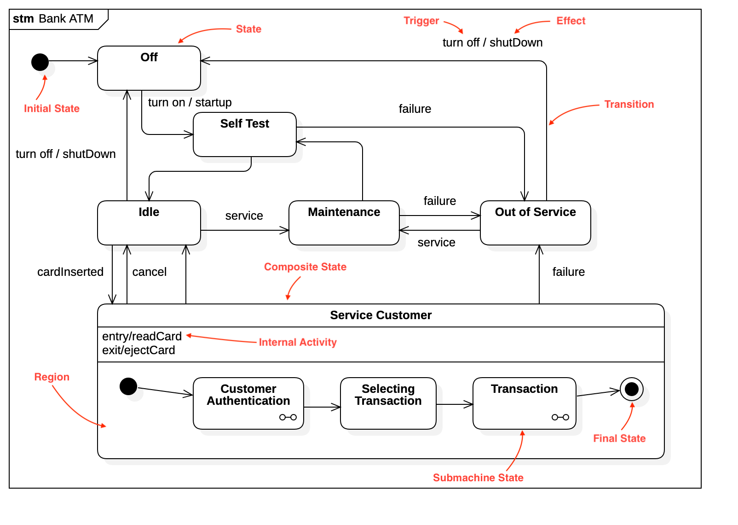

**UML Activity Diagram**

In UML, the activity diagram is used to demonstrate the flow of control within the system rather than the implementation. It models the concurrent and sequential activities.

The activity diagram helps in envisioning the workflow from one activity to another. It put emphasis on the condition of flow and the order in which it occurs. The flow can be sequential, branched, or concurrent, and to deal with such kinds of flows, the activity diagram has come up with a fork, join, etc.

It is also termed as an object-oriented flowchart. It encompasses activities composed of a set of actions or operations that are applied to model the behavioral diagram.

**Why use Activity Diagram?**

An event is created as an activity diagram encompassing a group of nodes associated with edges. To model the behavior of activities, they can be attached to any modeling element. It can model use cases, classes, interfaces, components, and collaborations.

It mainly models processes and workflows. It envisions the dynamic behavior of the system as well as constructs a runnable system that incorporates forward and reverse engineering. It does not include the message part, which means message flow is not represented in an activity diagram

It is the same as that of a flowchart but not exactly a flowchart itself. It is used to depict the flow between several activities.

**How to draw an Activity Diagram?**

An activity diagram is a flowchart of activities, as it represents the workflow among various activities. They are identical to the flowcharts, but they themself are not exactly the flowchart. In other words, it can be said that an activity diagram is an enhancement of the flowchart, which encompasses several unique skills.

Following are the rules that are to be followed for drawing an activity diagram:

1. A meaningful name should be given to each and every activity.
2. Identify all of the constraints.
3. Acknowledge the activity associations.

**Example of an Activity Diagram**

An example of an activity diagram showing the business flow activity of order processing is given below.

Here the input parameter is the Requested order, and once the order is accepted, all of the required information is then filled, payment is also accepted, and then the order is shipped. It permits order shipment before an invoice is sent or payment is completed.

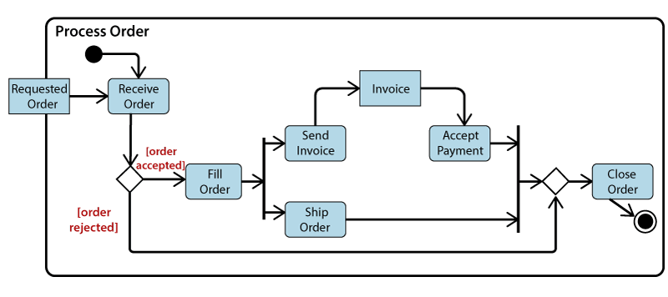

**When to use an Activity Diagram?**

An activity diagram can be used to portray business processes and workflows. Also, it used for modeling business as well as the software. An activity diagram is utilized for the followings:

1. To graphically model the workflow in an easier and understandable way.
2. To model the execution flow among several activities.
3. To model comprehensive information of a function or an algorithm employed within the system.
4. To model the business process and its workflow.
5. To envision the dynamic aspect of a system.
6. To generate the top-level flowcharts for representing the workflow of an application.
7. To represent a high-level view of a distributed or an object-oriented system.

**1. State chart for Hotel Management.**

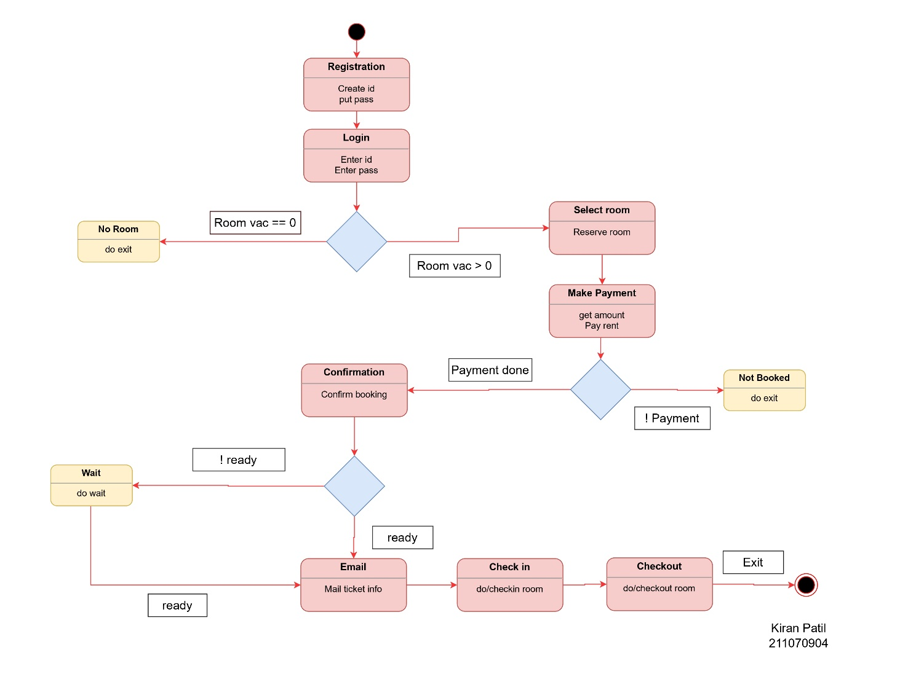

**2. Activity Diagram for Hotel Management system :**

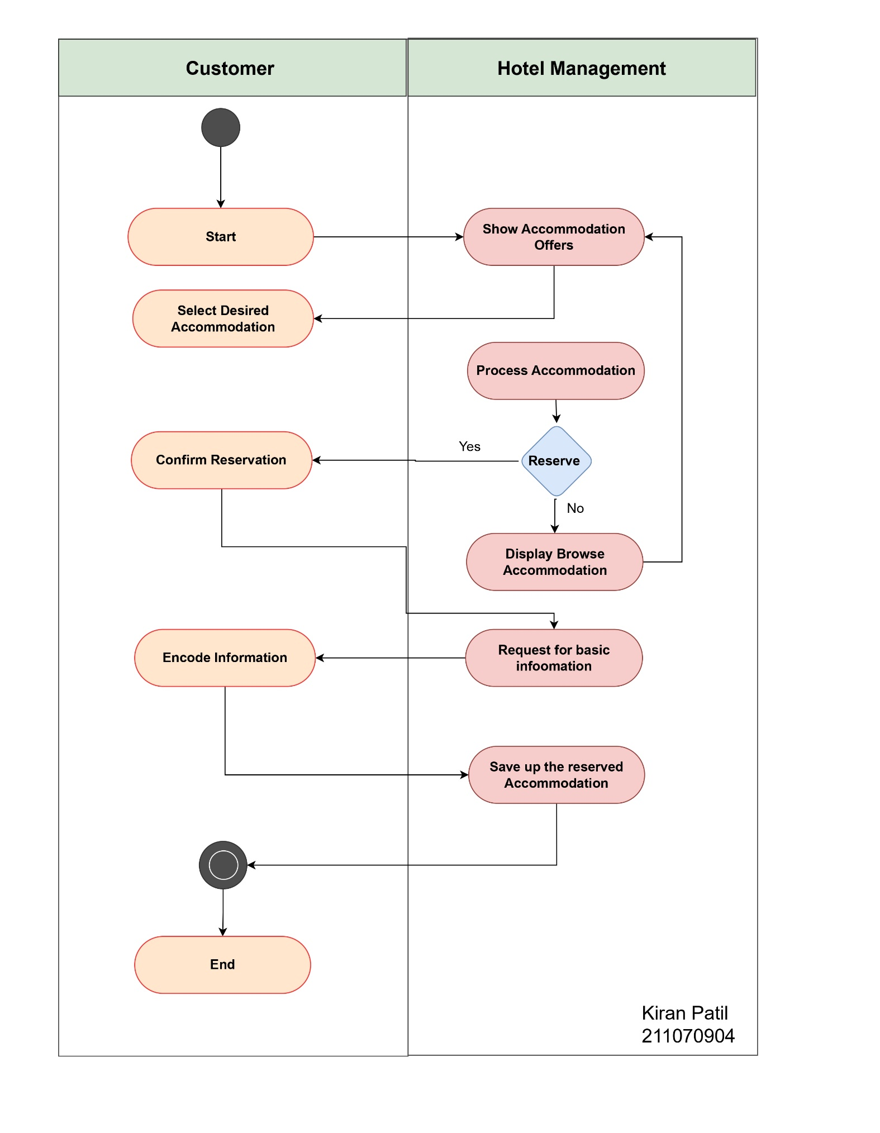

**3. State chart for Hotel Management**

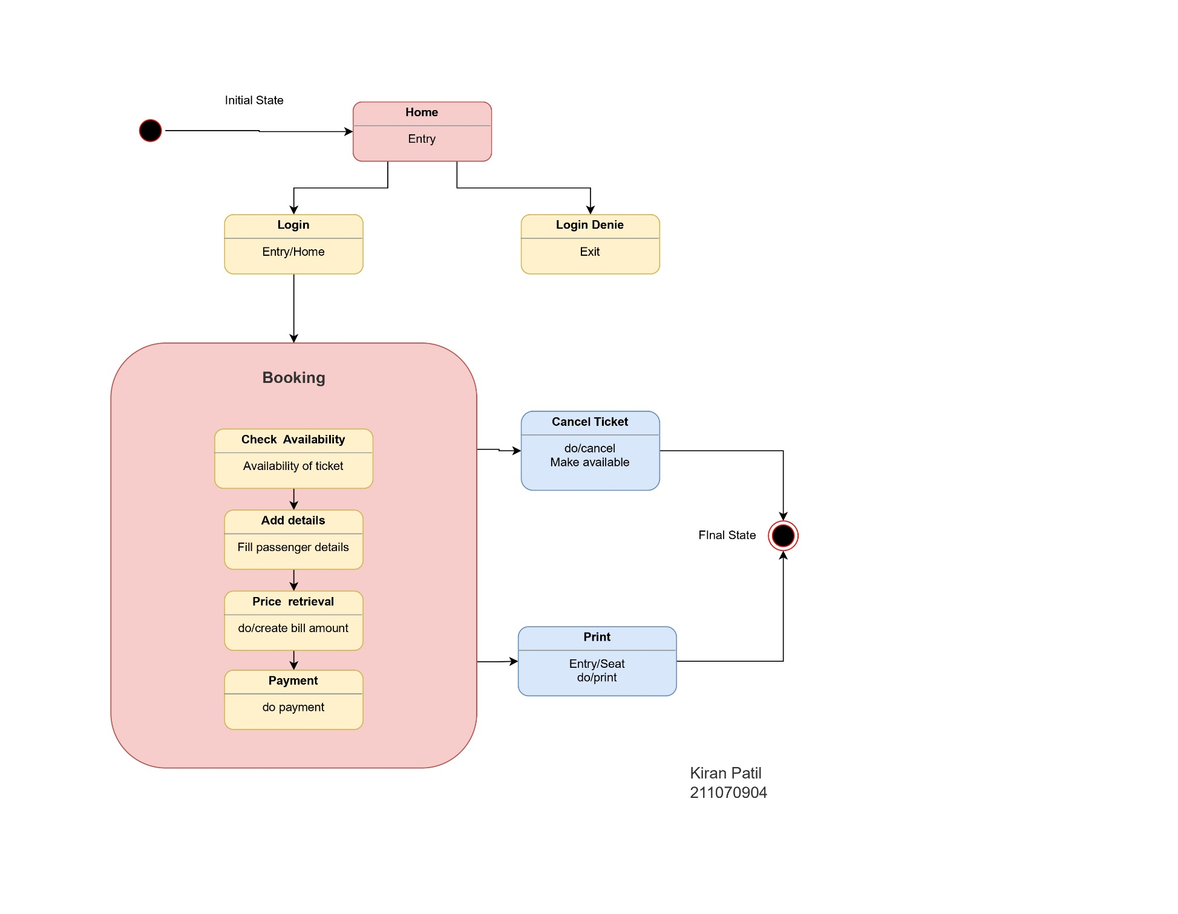

**4. Activity Diagram for Flight booking system .**

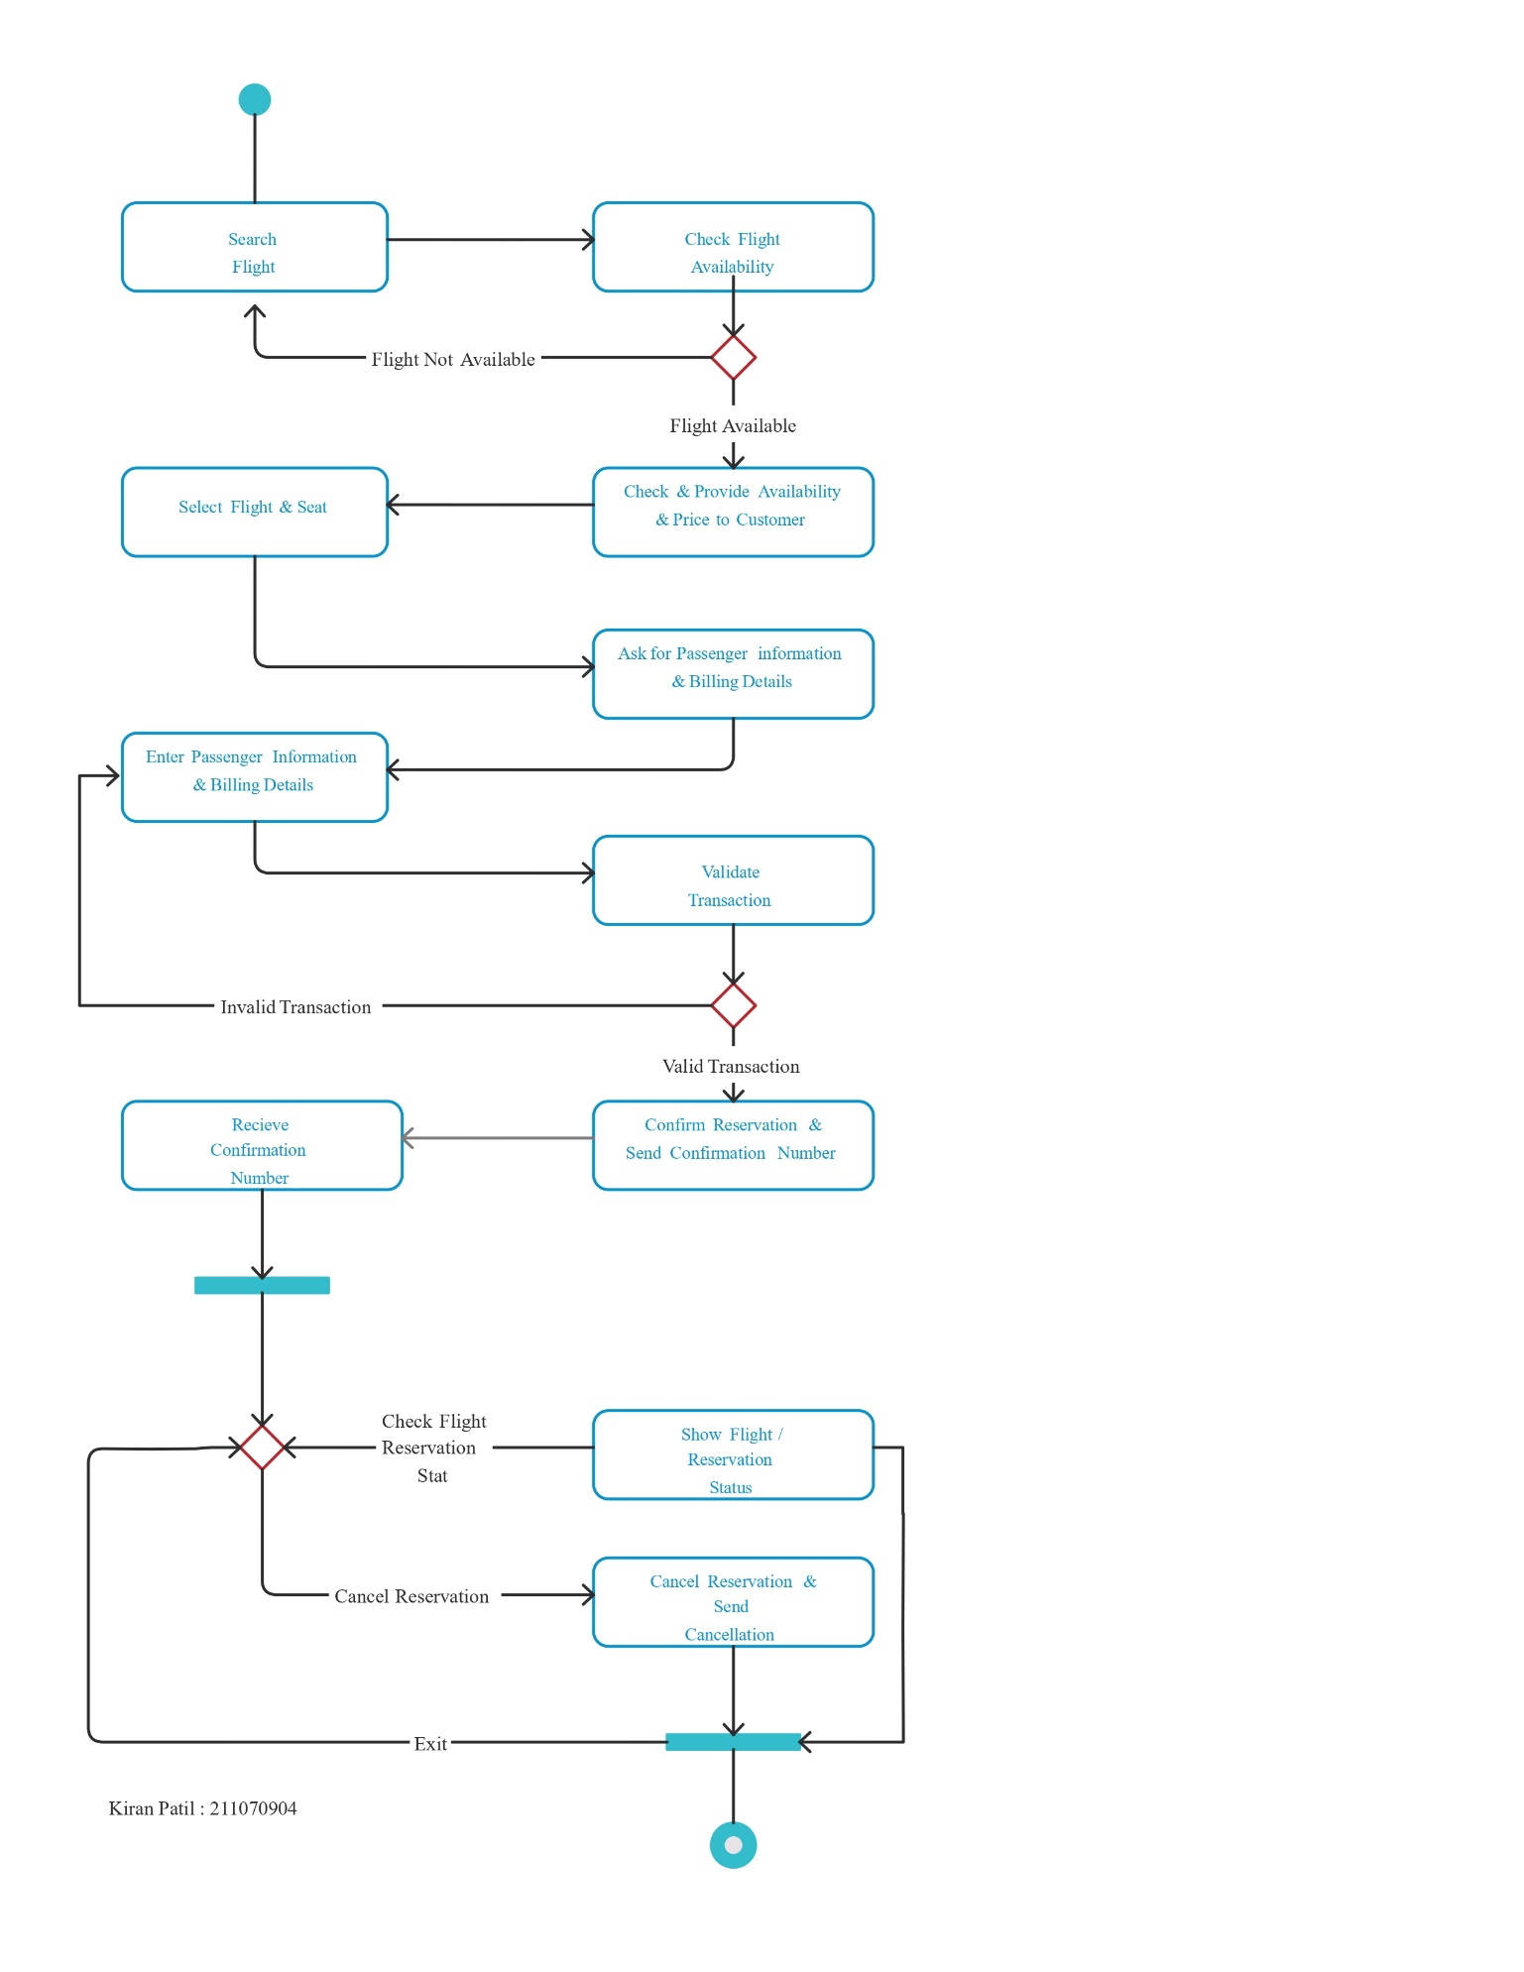

**Conclusion:**

* Thus from this experiment we can conclude that state chart and activity modeling are both important tools in software design and development.
* State charts are used to model the behavior of a system and the states it can be in, while activity modeling is used to model the flow of activities and actions within a system. Both state charts and activity modeling help developers to better understand and visualize the behavior of a system, which can aid in the design and implementation of more robust and efficient software systems.
* Ultimately, the choice between state chart and activity modeling will depend on the specific needs and requirements of the project at hand.